**John Perkins**

**Bonus Assignment 1**

**PREDICT 422**

**3/2/18**

The objective of this assignment is to perform cluster-wise regressions using the flexmix package in R.

**Data Exploration:**

The data was loaded into R as well as the necessary libraries to perform the analysis. Summary statistics were also pulled up for the data set.

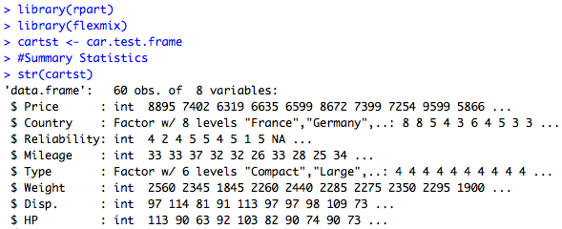

**Part 1 A:**

Cluster-wise regressions were calculated as a single cluster. The results can be seen below. The parameters for the analysis is also found below.

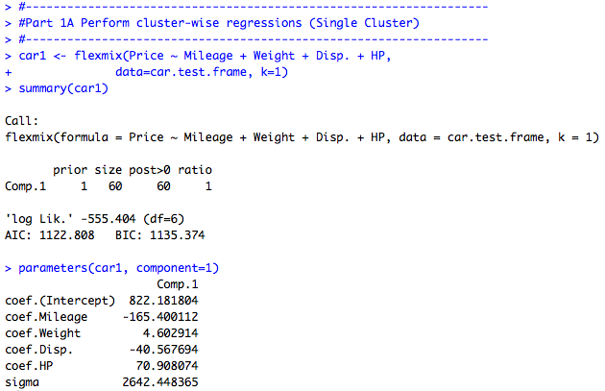

**Part 1 B:**

In this section, cluster-wise regressions were calculated as two clusters. The results can be seen below. The parameters are shown below as well.

